Tool Construction: Combustible Materials Test Report

Supplier: |  | Model No.:

It is Intel’s policy, under agreement with local code authority, that equipment, constructed with combustible plastic limit the quantity of plastic. Plastics Listed as “Non-fire-propagating” (FMRC 4910 and UL 2360 Class 1 or 2) are acceptable alternatives. (The UL 94 test methods are not acceptable for rating the flammability of plastics used in the construction of equipment located in clean rooms.) The minimum requirement is provided below. If you have any questions regarding applicable materials, acceptable listings or other concerns, please contact your EHS representatives.

Total weight of combustible plastic [kg or lbs]*: _______ (Total from Table A)
Total footprint (area) of the tool [sq.m. or sq.ft.]: _______
Metric (Weight/Area): _______

(Maximum Requirement < 1 lb./sq.ft. or 5 kg/sq.m.)

*Plastics meeting the FMRC 4910 or UL 2360 Class 1 or 2 Fire Test Protocols (i.e. plastic Listed as non-fire-propagating) need not be included it the total weight of combustible plastics. The UL 94 test method materials must be included in the weight of combustible plastics listed in Table A.

Please use Table A for tabulating any plastics that do not have FMRC 4910 or UL 2360 (Class 1 or 2) Listings. Small molded parts, plumbing and wiring insulation are not considered:
TABLE A | Material #1 | Material #2 | Material #3 | Material #4
Material
Weight – Total (lbs. or Kg.)
Applicable Test Data or other Relevant Flammability Data: May include UL-94V, ASTM E84, etc.)
Total Weight of Materials in Table A: _________________

Please use Table B for tabulating any noncombustible (optional) or sheet plastics that have FMRC 4910 or UL 2360 (Class 1 or 2) Listings. Also tabulate PVDF, PTFE, PFA, and PEEK materials on this table regardless of Listings.
TABLE B | Material #1 | Material #2 | Material #3 | Material #4
Material
Weight – Total (lbs. or Kg.)
Applicable Listing: FMRC 4910 or UL 2360 (Class 1 or 2). Noncombustible: N/C
PEEK, PFA, PTFE and PVDF: N/A

The steps that should be followed by the supplier:

- Calculate the mass of non-4910 material in all equipment and components in the Cleanroom/Fabrication level. Use Table A for tabulating any plastics that do not have FMRC 4910 or UL 2360 (Class 1 or 2) Listings. Small molded parts, plumbing and wiring insulation are not considered. Questions on the applicability of this small part exemption should be directed to the Intel EHS contact.

- Calculate the mass of all 4910 material in all equipment and components in the Cleanroom/Fabrication level. Use Table B for tabulating any noncombustible (optional) or sheet plastics that have FMRC 4910 or UL 2360 (Class 1 or 2) Listings. Also tabulate PVDF, PTFE, PFA, and PEEK materials on this table regardless of Listings.

- Calculate the floor area for the tool and support equipment in the Cleanroom. This area is equal to the sum of the tool footprint and the area between tools.

- Using the values obtained in steps 1 and 2, calculate the fuel density (mass/area).

Example:

1. Calculate the mass of non-4910 material in all equipment and components in the Cleanroom.

Location/Purpose | Mass (kg (lbs))
Wafer holders | 172 (378)
POC flanges | 140 (308)
Ducting | 56 (123)
Anode holders | 90 (198)
Miscellaneous | 34.5 (76)
TOTAL | 492.5 (1083)

2. Calculate the tool area. The layout for this tool with the most conservative spacing between adjacent tools

tool area = (2.5 + 23 + 2.1 + 2.5) ft x (1.5 + 7.5 + 1.5) ft = 348 ft2

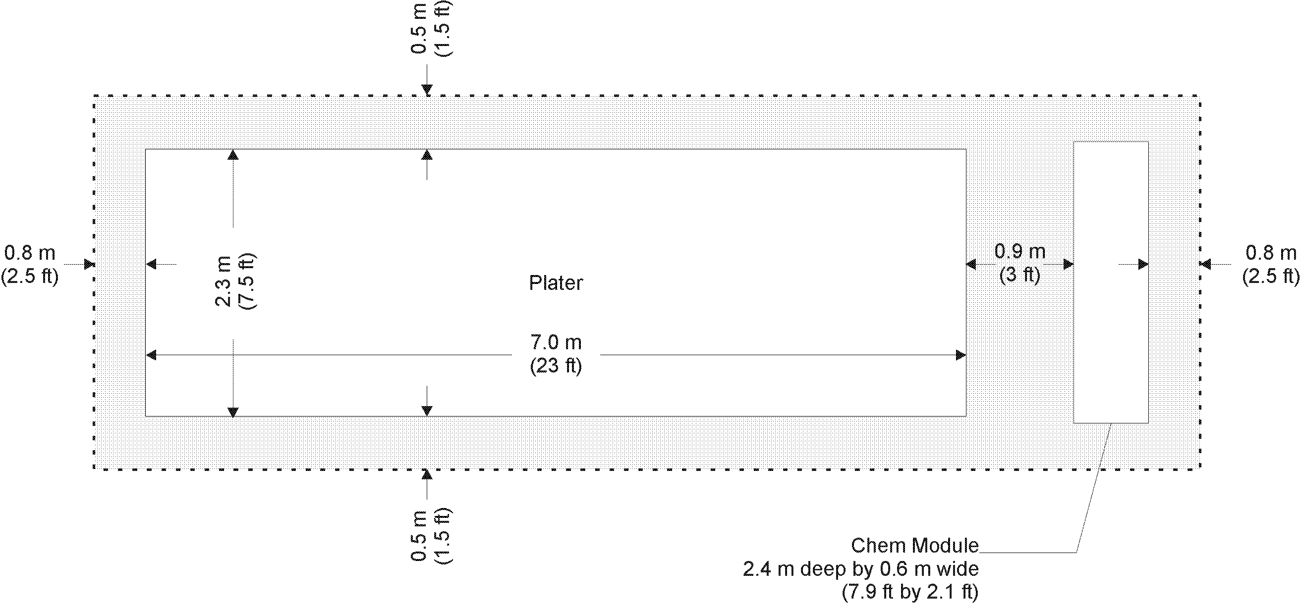

3. Calculate the fuel density.

mass/area = 282 lbs / 348 ft2 = 0.8 lbs/ ft2

